EX NO:06
DATE:
DECISION TREE

AIM:
To implement the concept of decision tree using a real world dataset and classify the new sample using it.

ALGORITHM:
Step 1: Start the program.
Step 2: Import the required libraries: pandas for data handling, matplotlib.pyplot for visualization, DecisionTreeClassifier and plot_tree from sklearn.tree and LabelEncoder from sklearn.preprocessing
Step 3: Create the dataset containing the attributes: Age, Income, Student, Credit Rating and Buys Computer (target class)
Step 4: Convert the dataset into a Pandas DataFrame.
Step 5: Initialize the LabelEncoder.
Step 6: Encode all categorical attributes into numerical values using label encoding.
Step 7: Separate the dataset into:
- Feature set X (Age, Student, Credit_Rating, Income)
- Target variable y (Buys_Computer)
Step 8: Create a Decision Tree Classifier using:
- Entropy as the splitting criterion
- Maximum tree depth of 3
Step 9: Train the Decision Tree model using the feature set X and target variable y.
Step 10: Display a message indicating successful model training.
Step 11: Initialize a plotting window with an appropriate figure size.
Step 12: Visualize the trained Decision Tree using plot_tree() by providing:
- Feature names
- Class names (Yes, No)
- Filled and rounded nodes
OUTPUT:
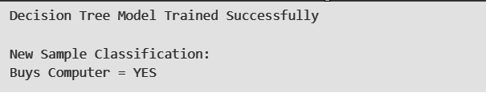

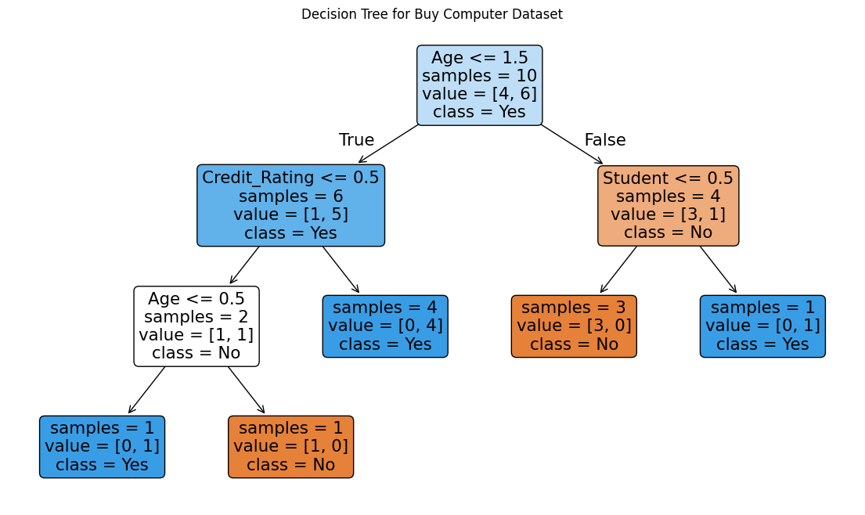
- Impurity values hidden
Step 13: Display the Decision Tree plot.
Step 14: Create a new test sample with encoded feature values.
Step 15: Predict the class label for the new sample using the trained model.
Step 16: Display the classification result as YES or NO.
Step 17: Stop the program.

PROGRAM:
import pandas as pd
import matplotlib.pyplot as plt
from sklearn.tree import DecisionTreeClassifier, plot_tree
from sklearn.preprocessing import LabelEncoder
data = {
'Age': ['Youth','Youth','Middle','Senior','Senior',
'Senior','Middle','Youth','Youth','Senior'],
'Income': ['High','High','High','Medium','Low',
'Low','Low','Medium','Low','Medium'],
'Student': ['No','No','No','No','Yes',
'Yes','Yes','No','Yes','Yes'],
'Credit_Rating': ['Fair','Excellent','Fair','Fair','Fair',
'Excellent','Excellent','Fair','Fair','Fair'],
'Buys_Computer': ['No','No','Yes','Yes','Yes',
'No','Yes','No','Yes','Yes']
}
df = pd.DataFrame(data)
le = LabelEncoder()
for col in df.columns:
df[col] = le.fit_transform(df[col])
X = df[['Age', 'Student', 'Credit_Rating', 'Income']]

y = df['Buys_Computer']
model = DecisionTreeClassifier(
criterion='entropy',
max_depth=3
)
model.fit(X, y)
print("Decision Tree Model Trained Successfully")
plt.figure(figsize=(14, 8))
plot_tree(
model,
feature_names=X.columns,
class_names=['No', 'Yes'],
filled=True,
rounded=True,
impurity=False
)
plt.title("Decision Tree for Buy Computer Dataset")
plt.show()
new_sample = pd.DataFrame({
'Age': [2], # Youth
'Student': [1], # Yes
'Credit_Rating': [1], # Fair
'Income': [2] # Medium
})
prediction = model.predict(new_sample)
print("\nNew Sample Classification:")
print("Buys Computer =", "YES" if prediction[0] == 1 else "NO")

PREPARATION | 20
IMPLEMENTATION | 30
VIVA | 15
RECORD | 10
TOTAL | 75

Result:
Thus the implementation of decision tree algorithm was successfully done and uploaded in the git ( https://github.com/Madhanalekha/MachineLearningLab )

